Aws cloud day 1

# configure MFA for aws account

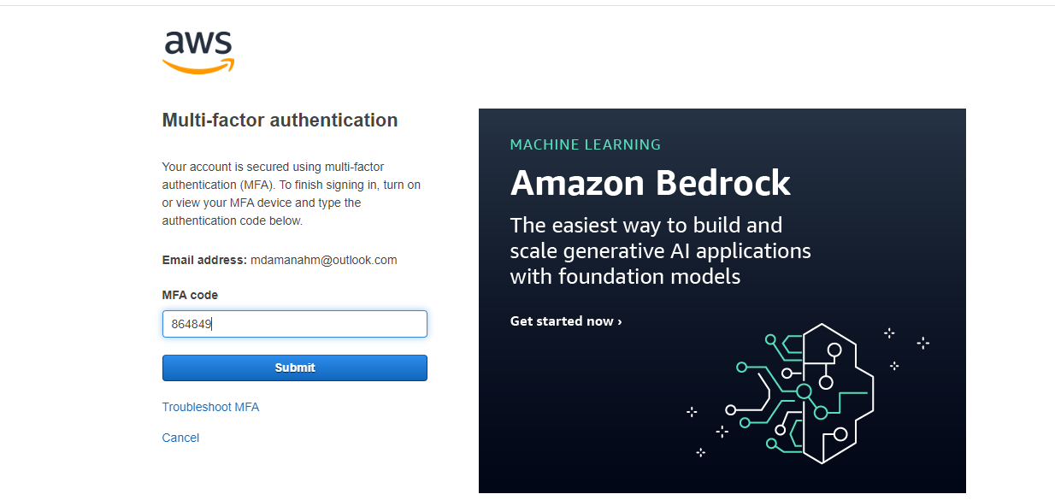

1. Install aws cli in windows.

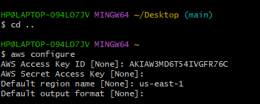

1. Setup ec2 in N.virginia region using aws cli command.

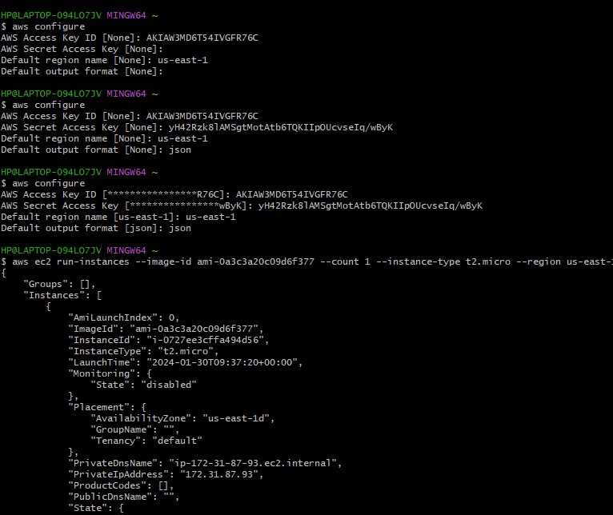

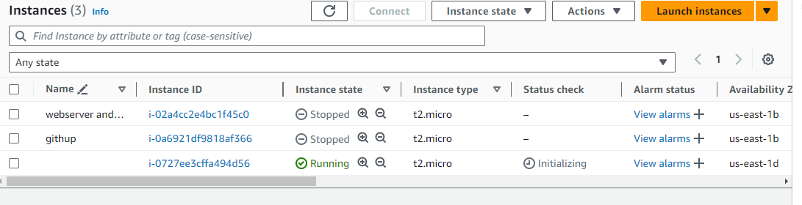

1. ) Setup security group in ohio region with name - Techie-sg and open port 22

Command use : aws ec2 create-security-group --group-name Techie-sg --description "Techie Security Group" --vpc-id vpc-03b95b5b4a398dd61 --region us-east-2

and open port 22

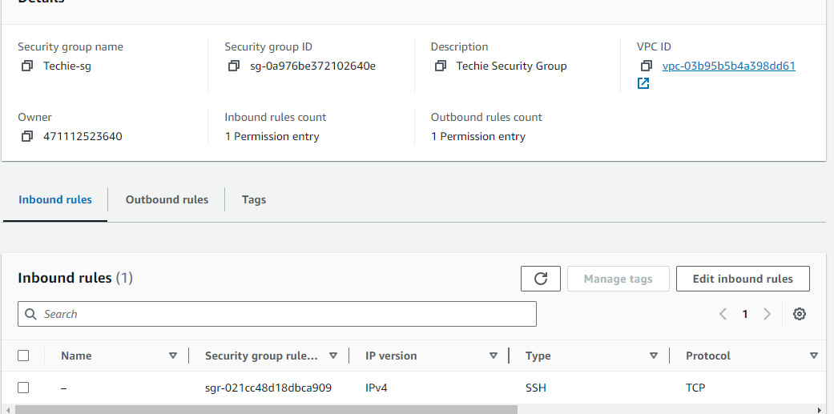

1. setup ec2,security group in Mumbai region using single aws cli command.

Using command aws ec2 create-security-group --group-name Techie-sg --description "Techie Security Group" --vpc-id vpc-0c925742edc273c60 --region ap-south-1



